Small Loads, efficiently stacked

Melkus Mechatronic presents new AGV for electronics production at LogiMAT 2025: At the Stuttgart LogiMAT 2025, Melkus Mechatronic will again be presenting itself as a reliable partner to warehouse logistics and production companies for highly available intralogistics transport solutions. From 11 to 13 March 2025, the independent Austrian manufacturer will exhibit the Melkus Rack Stacker BLS4060, a dynamic small AGV for flexible use in precision mechanics or electronics production, alongside its well-known automated guided pallet transporters in Hall 8, Stand 8C05.

Goeming/Salzburg, 22 January 2025 – Producing its high-availability AGVs, Melkus Mechatronic provides customers with uninterrupted in-house transport with maximum flexibility. At the LogiMAT 2025 show, the Austrian manufacturer will showcase the latest addition to its AGV fleet, the Melkus Rack Stacker BLS4060. Specifically designed to transport components to and from manual assembly stations, SMD machines and soldering stations as well as racks in electronics production, the nimble, flexible vehicle is designed for transporting PCB magazines and Euro-boxes up to 600 x 400 mm.

The Melkus Rack Stacker is based upon the ultra-compact Melkus C4060 autonomous transport robot. Due to its ultra-compact design (719 x 670 mm) and ability to turn on the spot, the AGV can navigate even in extremely confined spaces. The load is transferred by conveyor belt, optionally supported by an integrated RFID reader for load carrier identification. Although transfer heights of the lift range from 320 to 1,800 mm, the Rack Stacker is only 1,950 mm tall, allowing it to pass through standard doors. The on-board software ensures efficient execution of transport requests.

"As a reliable partner to warehouse logistics and production companies for highly available intralogistics transport solutions, we turn specific customer requirements into versatile solutions," explains Melkus Mechatronic CEO Martin Lindner. "The Melkus Rack Stacker BLS4060 is our contribution to increasing flexibility and reducing space requirements in electronics and precision mechanics production."

Along with the Melkus Rack Stacker BLS4060, Melkus Mechatronic will also exhibit the autonomous pallet transporters HLG120 and G130 that have proven themselves in daily use in numerous projects. In addition to their application-specific payload and lifting height and the space-saving drive, these intelligent transport robots excel with their robust design and singularly high availability. "Based on these high-availability AGVs, we provide our customers with flexible in-house transport with maximum reliability," confirms Martin Lindner. "That's why Melkus Mechatronic is the M&M of transport robotics for the Alpha & Omega of intralogistics."

Melkus Mechatronic at LogiMAT: 11 – 13 March 2025 in Stuttgart; Hall 8, Booth 8C05.

Image Captions
The Melkus Rack Stacker BLS4060 is the star of the Melkus Mechatronic LogiMAT exhibit in Hall 8, booth No. 8C05 for the space-saving and efficient transport of PCB magazines and Euro-boxes in electronics and precision mechanics production.  All images: Melkus Mechatronic | 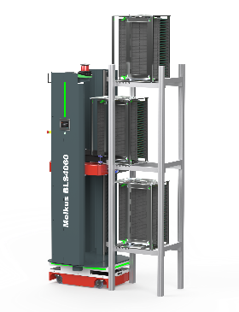
The Melkus HLG120 autonomous guided pallet transporter excels with its robust design and high availability. | 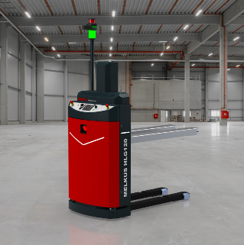
Martin Lindner, CEO of Melkus Mechatronic:  "The Melkus Rack Stacker BLS4060 is our contribution to increasing flexibility and reducing space requirements in electronics and precision mechanics production." | 

About Melkus Mechatronic
Melkus Mechatronic GmbH is an innovative technology company based in Salzburg. With more than ten years of experience in the field of AGVs and mobile robotics, it provides customers with highly available AGVs for flexible in-house transport with maximum reliability. Swiftly installed and commissioned, these enable Melkus operators to organise their intralogistics more efficiently and to establish resource-saving processes. Melkus employs highly qualified and committed staff and offers a range of six AGVs for a wide variety of applications. www.melkus-mechatronic.com

